Title (Times New Roman 14) Title Should be Assertive and Short (2-3 lines; max. 3 lines)
First Author (First Name Last Name)1, Second Author (First Name Last Name)2 and Third Author (First Name Last Name)3* (Times New Roman 10)
¹ Department of Geotechnical Engineering, School of Engineering, Polytechnic of Porto, Porto, Portugal
² Department of Georesources, University of Princeton, Princeton, USA
³ Laboratory of Geosystems, University of Freiberg, Germany (Times New Roman 9)
*corresponding author: only@isep.ipp.pt (Times New Roman 8)
Abstract. The abstract should summarize the chapter's contents in brief (200-250 words; max 250 words/min 200). Please insert it here. Never use references in the abstract. (Times New Roman 9).
It should include the following:
• Context/Purpose: One to two sentences explaining why you studied this particular topic and its significance. Has past research been done? How does your research add to existing knowledge?
• Methods: Explain why you studied the topic and its significance in one to two sentences. How did you collect your data? How did you process your data?
• Results: Three to four sentences about what you found through your research.
• Discussion/Interpretation: Up to four sentences discussing those findings. What do the results mean?
• Final Remarks: One sentence summarizes what you learned from your research and why it is significant.
Keywords: First Keyword, Second Keyword, Third Keyword, Fourth Keyword, Fifth Keyword. (Each keyword should include two or three compound words; Times New Roman 9)

Please note: The AI-contribution using generative AI tools shall be zero.
- Introduction (Times New Roman 12)
Please insert here an Introduction (Times New Roman 10). Please note that the first paragraph is not indented. The first paragraph that follows a table, figure, equation, etc., does not have an indent, either.
Subsequent paragraphs, however, are indented (here insert the second paragraph). For citations of references in the text, please use: Author (2016), Author and Author (2014), Author et al. (2015)
- Regional Setting or Methods or Materials and Methods or Brief State of Art… etc. (Times New Roman 12)
Please insert here the Second Section (Times New Roman 10). Please note that the first paragraph is not indented. The first paragraph that follows a table, figure, equation, etc., does not have an indent, either.
Subsequent paragraphs, however, are indented (here insert the second paragraph). For citations of references in the text, please use: Author (2016), Author and Author (2014), Author et al. (2015)

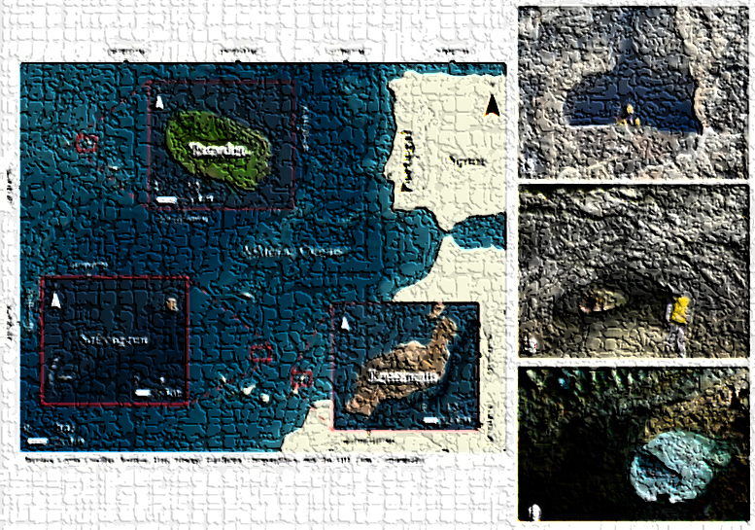

Fig. 1. A figure caption is always placed below the illustration. (Source: Author).

Short captions are centered, while long ones are justified. (Times New Roman 9). Dimensions of figures: width max 15cm. For figures with maps, always include a scale bar (with units in the International System), a north arrow, and a geographical grid. The figures must also be shared as part of the MS Word file and as separate high-resolution TIFF or JPEG files (min. 300 dpi). Remember, in the intra-figure, the font size shall be 7 points, in Arial. Please share the vector format (e.g., a GIS shapefile or CAD file) if available.

Please note: Mention the source of all figures and tables in-text, such as: (Source: Author)
- Results (Times New Roman 12)
  - Results (Subsection Sample / Only if needed!) (Times New Roman 10)
Please insert here the Third Section (Times New Roman 10). Please note that the first paragraph of a section or subsection is not indented. The first paragraphs that follow a table, figure, equation, etc., do not have an indent, either.
Subsequent paragraphs, however, are indented (here insert the second paragraph).

  - Results (Subsection Sample / Only if needed!) (Times New Roman 10)
Please insert here the Third Section (Times New Roman 10). Please note that the first paragraph of a section or subsection is not indented. The first paragraphs that follow a table, figure, equation, etc., do not have an indent, either.
Subsequent paragraphs, however, are indented (here insert the second paragraph). Please see below how to insert Table 1 and Fig. 1 in the text.
Table 1. Table captions should be placed above the tables. (Source: Author) (Times New Roman 9).
Results | Results | Results
Results | Results | Results
Results | Results | Results
Results | Results | Results
Results | Results | Results
Use Ms. Excel to prepare your tables; they must be shared separately from the text.
If applicable, displayed equations are centered and set on a separate line.
x + y = z (1)
Please avoid rasterized/scanned/photographed images for line-art diagrams, schemas, and maps. Use vector graphics instead (see Figs. 1 and 2). Remember, the font size shall be 7 points (min.), and the type shall be Arial.

Fig. 2. A figure caption is always placed below the illustration. Short captions are centered, while long ones are justified. (Source: Author). (Times New Roman 9).

  - Results (Subsection Sample / Only if needed!) (Times New Roman 10)
Please insert here the Third Section (Times New Roman 10). Please note that the first paragraph of a section or subsection is not indented. The first paragraphs that follow a table, figure, equation, etc., do not have an indent, either.
Subsequent paragraphs, however, are indented (here insert the second paragraph).
- Discussion (Times New Roman 12)
Please insert here the Fourth Section Discussion, which should be the most detailed section (Times New Roman 10). Please note that the first paragraph of a section or subsection is not indented. The first paragraphs that follow a table, figure, equation, etc., do not have an indent, either.
Subsequent paragraphs, however, are indented (here insert the second paragraph). For citations of references in the text, please use: Author (2016), Author and Author (2014), Author et al. (2015)

- Conclusions (Times New Roman 12)
Please insert here the Fifth Section (Times New Roman 10). Please note that the first paragraph of a section or subsection is not indented. The first paragraphs that follow a table, figure, equation, etc., do not have an indent, either. Avoid bibliographic citations.
Subsequent paragraphs, however, are indented (here insert the second paragraph).

Acknowledgments (Times New Roman 12)
Please insert here the Sixth Section (Times New Roman 9). Is optional.

References (Times New Roman 12)
Please note:
- Translate references (work title) in other languages into English.
- Do not use unpublished sources. Also, unreliable sources such as Wikipedia are not acceptable.
- Avoid excessive use of link sources. Only the strictly necessary and reliable web sources. If possible, none.
- Please note that the minimum number of references is 12.
- The number of self-citations of any author is 0 (zero). That is mandatory.

Author F. (2025). Article title. Journal of Geological and Geotechnical Engineering, 2(5), 99–110. https://doi.org/10.1007/s111069-011-0124-3
Author F., Author S. (2025). Title of a conference proceedings chapter. In: Editor, F., Editor, S. (eds.) Conference of the Engineering Geosciences: Status and Trends, ISRM, vol. 79, pp. 20–55. Publisher, Location. https://doi.org/10.1006/s111079-012-0085-4 [DOI: if available]
Author F., Author S., Author T. (2025). Book title. 2nd edn. Publisher, Location. https://doi.org/10.1007/s111069-012-0095-3 [DOI: if available]
Author F., Author S., Author T., Author W. (2025). Contribution title. In: Abstracts of the 9th International Conference on Hazard Geotechnics, pp. 7–8. Publisher, Location. https://doi.org/10.1007/s111079-012-0005-4 [DOI: if available]
Author F. (2025). Title of MSc Dissertation or PhD Thesis. University of Minho, Braga (PhD Thesis or MSc Dissertation). URI: https://hdl.handle.net/16316/66666 [URI: if available]
SN Homepage: http://www.springer.com/ (accessed on June 2026).
(Times New Roman 9)
Avoid excessive use of links. Only the strictly necessary. If possible, none.

Please note:
- The manuscript should be in good English (please use UK or USA spelling, not mixed). If needed, please contact an English language editing service before submitting.
- Do not use unpublished sources. Also, unreliable sources such as ‘Wikipedia’ are not acceptable.
- Please note that the minimum number of references is 12.
- The number of self-citations of any author of your contribution is 0 (zero). That topic is mandatory.
- Please carefully read the template before preparing the chapter book (“full paper” format), and do not exceed 25 pages in length. The minimum number of pages accepted is 15, and the maximum is 25, including figures, tables, and a bibliography.
- Figures and tables files must be shared separately from the text manuscript file. The figures (TIFF or JPEG – 300 dpi) or tables (Ms Excel) are no more than 15 cm wide.
- According to the publisher's office, a high Similarity Index (SI) percentage (spotted as ‘Plagiarism’) in any form/type may lead to the rejection of chapters and/or the complete manuscript. Global SI % must be ≤ 12 % for each chapter (and ≤ 4% per source used in each chapter).
The handling editor (Helder I. Chaminé – hic@isep.ipp.pt) could support the SI% check with the Turnitin Software Tool. In case of high SI % detection, the handling editor will share the report so the authors can fix the issues.
- Key dates: i) deadline chapter book submission by authors – 15th December 2026 (compulsory); ii) peer-review process by international experts (with 1 or 2 turns around of each chapter) – until 31st July 2027; iii) final check to all chapters and editorial issues – before November 2027; iv) Formal submission to the SN office (Springer Series) and editorial evaluation by publisher – 23rd December 2027; v) Book publishing by Springer – tentatively before mid-2028.

